Health workforce Rural pathway or pipeline approach in the sub-Sahara countries

Achieving sustainable development goal target 3.c of substantially improving health workforce density and equitable distribution in developing countries by 2030 requires implementation of effective HWF development interventions in years ahead. Based on evidence produced over the last two decades, targeted admission policies that enroll students with a rural background in health worker education programmes represents the most effective HWF strategy for attracting, developing, and retaining health workers in rural and remote areas.
In March 2016, the United Nation Secretary General established a High-Level Commission on Health Employment and Economic Growth that made ten key recommendations to "stimulate and guide the creation of at least 40 million new health and social sector jobs, and reduce the projected shortage of 18 million health professionals, mainly in low- and lower-middle-income countries, by 2030"
SADC and WAEMU countries have responded to the call of the UNSG to translate the Commission recommendations into actions. In 2016, a WAEMU subregional action plan was developed and adopted during The Ministerial meeting of Employment and Health sectors of the WAEMU countries to strengthen Economic Growth and Employment for Health. The action plan adopted was targeting youth and women employment.
At the global level, the Working for Health Multi-Partner Trust Fund was established to support 47 low-income countries, including countries in the francophone Africa, to support them in filling the gap for health workforce requirements in achieving SDGs. the WAEMU countries subregional plan included strategies to improve equity in the distribution of the health workforce and to ensure their availability in the rural and remote areas. For the implementation of the subregional WAEMU plan, countries have developed their National Action Plan for investment in health and social sector jobs and economic growth focusing on their own priorities.
in 2021, WHO revised and published the retention guideline on health workforce development, attraction, recruitment and retention in rural and remote areas. This guideline has highlight success strategy such as the rural pathway or pipeline to improve access to the health services in the remote and rural areas.
The “rural pipeline” or pathway (RP) approach suggests that health professionals in training should (i) be recruited – to the extent possible – from rural areas, (ii) be trained in rural areas, (iii) have maximum exposure to rural clinical cases and (iv) be posted in areas where they are coming from. In a nutshell, the “rural pipeline” approach is about training health workers from rural areas, in rural areas and for (practicing in) rural areas, and ensuring their recruitment and support in rural areas once they graduate. The approach is based on evidence from a number of countries and studies showing that students from rural areas have a higher probability to stay or work in these areas than their urban counterparts. In other words, the RP approach is focusing on students that are intrinsically interested and feel comfortable to work in rural areas after their graduations, as opposed to interventions that try to force or incentivize urban students to work there.
A rural pipeline or pathway approach

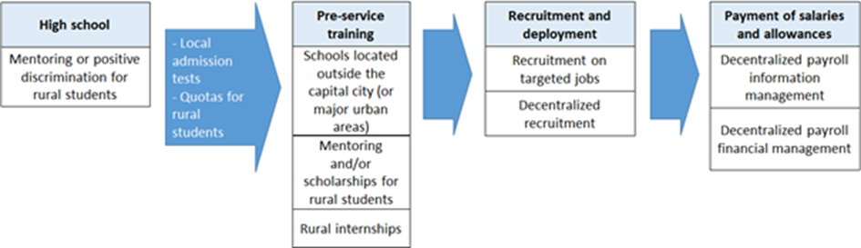

Rural pathway or pipeline implementation is relatively new to SSA settings. However, there exists well known documented experiences from countries like Ethiopia, South Africa, Uganda, Malawi, and Mali. For instance, Mali has more than 20 years of rural pathway implementation experience with medical doctors living and practicing in rural areas and nurses and midwives training and recruitment in the province of Gao.
Dormael and colleagues in their study on recruiting medical doctors to rural districts found that preferential selection of students with rural background and their exposure to rurally relevant training packages enhanced their self-confidence, job-satisfaction and retention during the three years of the project lifespan in rural Mali. Authors have also reported the positive outcomes of rural pipeline programs on the attitudes, specialty choice, and intentions of HWs to practice in rural areas; and their performance in local health care systems in Africa. Nonetheless, the successful implementation of these strategies is context-dependent. Factors that hinder the sustainability of these strategies include financial, governance and managerial challenges,
Guinea has adopted the rural pathway approach in 2016 in 8 provinces with limited success. A case study of Guinea experience is on development.
Niger has taken ownership of the Commission recommendations and translated them into a National Action Plan for investment in health and social sector jobs and economic growth (P.A.N-Niger), for the period 2018-2021. The plan has been reviewed in 2022 and extended for the period of 2023 -2028.
The rural pathway program of Niger has been developed with the technical and financial support of WHO in Niger. An inclusive process has been used to develop the program under the leadership of the Minister of Employment. A technical committee was established involving 6 ministries for the development of the program (Secretary-generals, First technical and political leaders of the following ministries: Employment, Health, Education, Agriculture, Plan, Finance). Governmental and parliamentary seminars were organized for a widely consultations. was adopted by a presidential decree and resources mobilization has been done. The plan is now included in the new economic and social development plan of Niger as an operational plan of the national economic development strategy. Resources mobilization is still ongoing with the technical support of WHO country office.
Rural pipeline or pathway key area of interventions in Niger:
Component 1: Improving the quality of youth training: Primary and secondary training, Professional and technical training, including health workforce training
Component 2: Job creation especially targeting youth and women for economic growth: Strengthening the legislative and regulatory framework for an effective local public service, Identifying conditions to facilitate the creation of decent jobs (public and private recruitment, entrepreneurship).
Component 4: Effective management coordination of the Rural Pipeline Program : Effective governance: Strengthening advocacy, social mobilization, Accountability, Monitoring and Evaluation and Capitalization of Prior Learning

World Health Organization. WHO Guideline on Health Workforce Development, Attraction, Recruitment and Retention in Rural and Remote Areas.; 2021.
Health workforce development, attraction, recruitment and retention in rural and remote areas guideline, WHO, 2021 https://www.who.int/publications/i/item/9789240024229
Dormael M Van, Dugas S, Kone Y, et al. Human Resources for Health Appropriate training and retention of community doctors in rural areas : a case study from Mali. 2008 ;8:1-8. doi:10.1186/1478-4491-6-25

